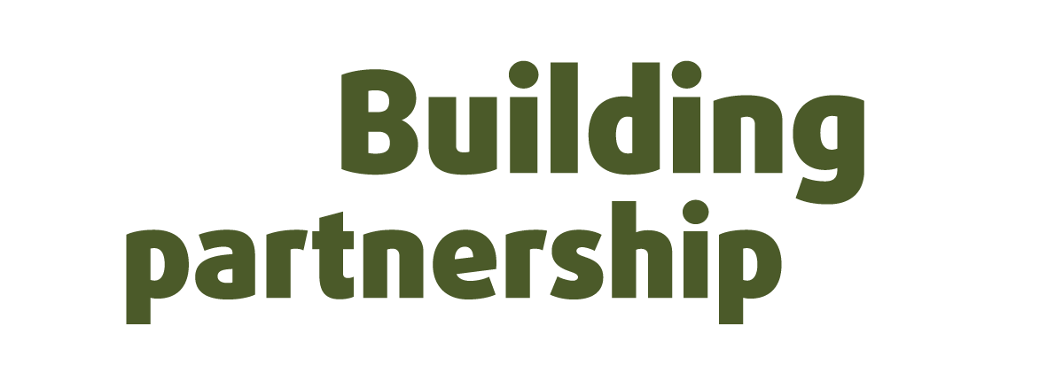
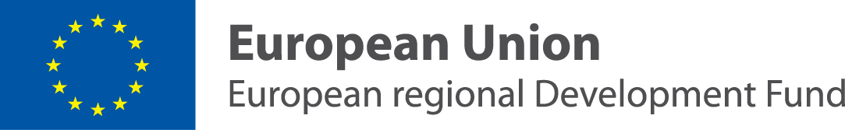
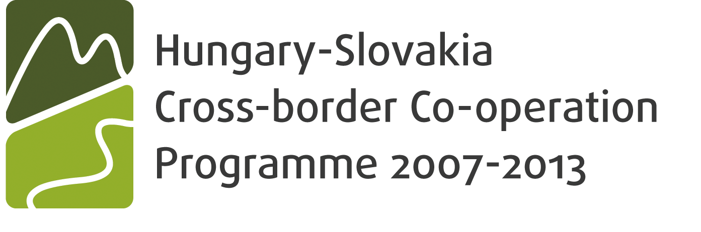

Seminar
Local government spending and public procurement

Seminar is a part of the project:

„Building the network for increasing capacity to strengthen sustainability of transparent local governments in Slovakia and Hungary“

November 14, 2011
Bajkalská 25, 827 18 Bratislava, Slovakia

Program

10:50 – 11:00 | Opening
11:00 – 11:20 | Electronic reverse auctions in Slovakia  Doc. Ing. Emília Sičáková – Beblavá, PhD.
11:20 – 11:40 | Discussion
11:40 – 12:00 | Financing in Hungarian local self-governments - from aspects of transparency  Dr. Adrián Fabián
12:00 – 12:20 | Discussion
12:20 – 12:50 | Break for lunch
12:50 – 13:10 | Access to information and management of property in companies controlled by local governments  Mgr. Ivan Rončák
13:10 – 13:30 | Discussion
13:30 – 13:40 | Closing remarks

About project

The seminar is a part of the activities implemented within the project of Transparency International Slovakia and Transparency International Hungary called Building the network for increasing capacity to strengthen sustainability of transparent local governments in Slovakia and Hungary which aims at strengthening capacities of good governance and decision-making processes in local governments in both Slovakia and Hungary. This, eventually, should serve as a baseline for fight against corruption at the decentralized level of public sector administration. This project is a part of the Hungary-Slovakia Cross-border Co-operation Programme 2007-2013.

We would be very pleased if you could participate in this seminar and become a part of this cross-border effort to improve transparency and decision-making in local governments in Slovakia and Hungary.

Travel instructions and venue of the event
Seminar takes place on Monday, November 14, 2011 from 10:50 to 13:40.
The official venue of the event is: COOP Jednota, Bajkalská 25, 827 18 Bratislava

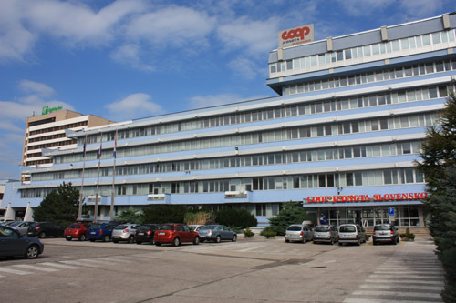
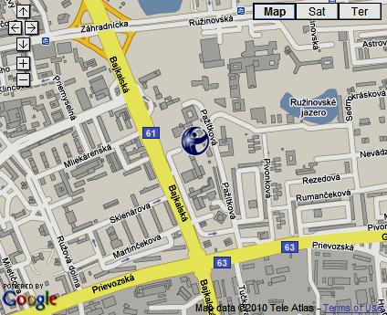

Language:
The seminar will be held in Slovak and Hungarian. The simultaneous interpretation is secured.

Parking
Parking is in front of and behind the building and is charged.

Catering
Lunch and refreshment is secured.

Fee for participation
The participation including catering is for free.

Please, confirm your participation by November 8, 2011. You can do this by e-mail or by phone. The contact is: Slavomíra Šatníková, satnikova@transparency.sk, 02/5341 7207

