70% of governments fail to protect against corruption in the defence sector
New index also finds that half of countries do not publish their defence budget, or provide only very limited aggregate information

London, 29 January 2013 – Seventy per cent of countries leave the door open to waste and security threats as they lack the tools to prevent corruption in the defence sector, according to the first ever index measuring how governments prevent and counter corruption in defence, released by Transparency International UK’s Defence and Security Programme. Those with poor controls include two-thirds of the largest arms importers and half of the biggest arms exporters in the world.
Germany and Australia are the only countries that have strong anti-corruption mechanisms according to the index, with measures in place such as robust parliamentary oversight of defence policy, stringent standards expected of defence companies, and accountable intelligence services. Nine countries ̶ Algeria, Angola, Cameroon, DRC, Egypt, Eritrea, Libya, Syria, and Yemen ̶ exhibit critical risk, lacking basic measures such as controls to enable accountability, making institutionalisation of anti-corruption mechanisms in the sector near impossible. South America and Eastern Europe, on the other hand, show lower risk of corruption thanks to strong technical controls in areas such as administration of audits.
The Government Defence Anti-Corruption Index analyses what 82 countries do to reduce corruption risks. These countries accounted for 94 per cent of the global military expenditure in 2011, equivalent to USD 1.6 trillion. Countries are scored in bands from very low risk (A) to critical risk (F) according to detailed assessment across 77 indicators that cover five prominent risk areas in the sector: politics, finance, personnel, operations, and procurement.
“Corruption in defence is dangerous, divisive and wasteful, and the cost is paid by citizens, soldiers, companies and governments. Yet the majority of governments do too little to prevent it, leaving numerous opportunities to hide corruption away from public scrutiny and waste money that could be better spent,” explains Mark Pyman, Director of Transparency International UK’s Defence and Security Programme.
Transparency International calls on governments to make this traditionally secretive sector, which involves large public contracts, more open. Defence establishments should increase citizens’ access to information about defence budgets and procurement. Legislators should have stronger controls and oversight of the sector, possessing the teeth and access to cut corruption down.
Transparency International estimates the global cost of corruption in the defence sector to be a minimum of USD 20 billion per year, based on data from the World Bank and the Stockholm International Peace Research Institute (SIPRI). This equates to the total sum pledged by the G8 in 2009 to fight world hunger.
Politicians exercise little oversight. Armed Forces fear blowing the whistle. Citizens are kept in the dark.
The Index shows that only 15 per cent of governments assessed possess political oversight of defence policy that is comprehensive, accountable, and effective. In 45 per cent of countries there is little or no oversight of defence policy, and in half of nations there is minimal evidence of scrutiny of defence procurement.
The study also finds that citizens are frequently denied basic knowledge about the defence sector. Half of the countries’ defence budgets lack transparency entirely, or include only very limited, aggregated information. In 70 per cent of the countries, citizens are denied a simple indication of how much is spent by their government on secret items.
According to Dr. Oliver Cover, the principal author of this study, “this Index shows unequivocally that there is a severe risk of corruption in this sector. It is a shock that in some areas it is also so poorly understood, for example in conflict situations, where corruption can become deeply embedded. Our index will help everyone to understand and address the risks. Governments should clean up this sector, and our report will give them practical solutions to achieve transparency. Doing so will save the lives of troops and citizens—and governments billions of dollars.”

Notes to editors

- The Index is the sister index of the Defence Companies Anti-Corruption Index, released on 4th October 2012, which evaluated the capacity of 129 defence companies to address corruption risk.

- Visit http://government.defenceindex.org for detailed assessments of the 82 countries amounting to over one million words of analysis.

- Transparency International UK’s Defence and Security Programme helps to build integrity and reduce corruption in defence and security establishments worldwide through supporting counter corruption reform in nations, raising integrity in arms transfers, and influencing policy in defence and security. To achieve this, the programme works with governments, defence companies, multilateral organisations and civil society. The programme is led by Transparency International UK (TI-UK) on behalf of the TI movement. For more information about the programme please visit www.ti-defence.org.

ANNEX 1: OVERALL RESULTS
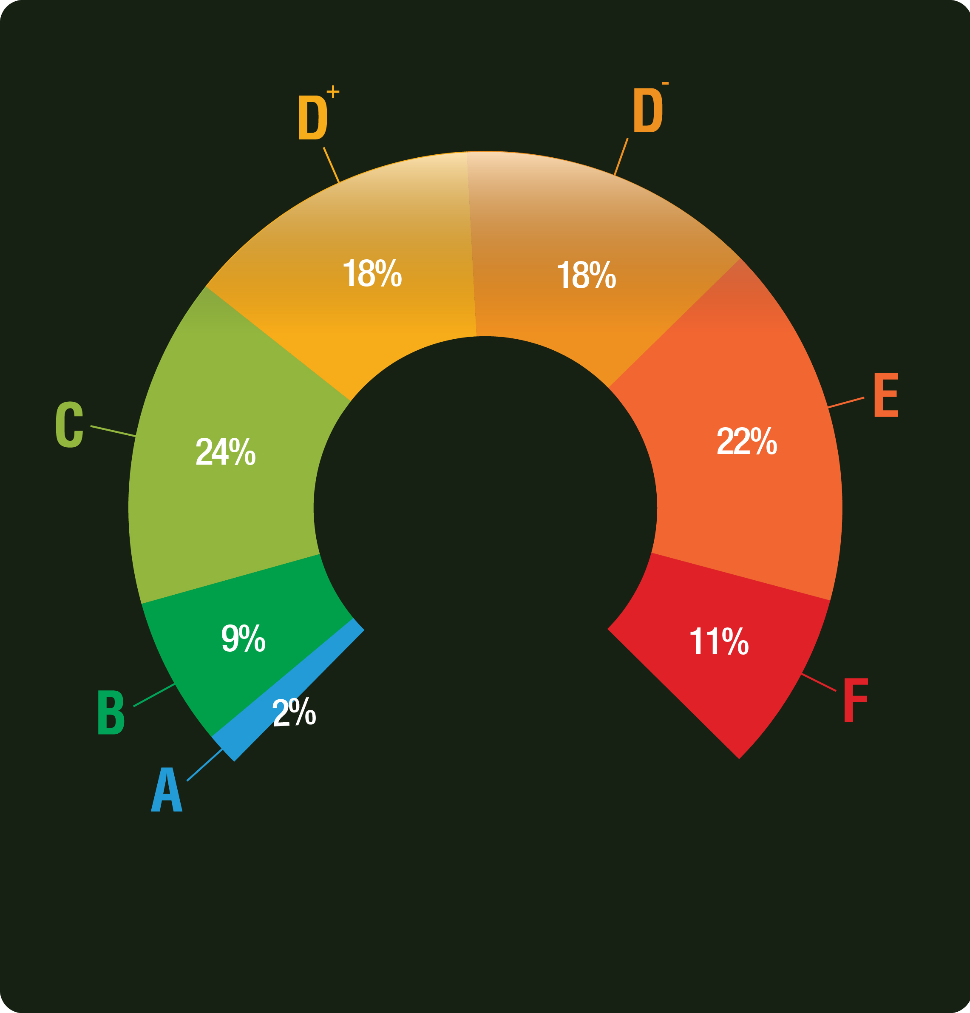
The Index bands countries according to their level of risk of corruption. The risk of corruption is determined by the danger and extent of it occurring and by the frequency citizens may face it.
BAND A – Very Low Risk (2 COUNTRIES): Australia, Germany
BAND B – Low Risk (7 COUNTRIES): Austria, Norway, South Korea, Sweden, Taiwan, United Kingdom, United States
BAND C – Moderate Risk (16 COUNTRIES): Argentina, Brazil, Bulgaria, Chile, Colombia, Croatia, Czech Republic, France, Greece, Hungary, Italy, Japan, Latvia, Poland, Slovakia, Spain
BAND D+ - High Risk (15 COUNTRIES): Bosnia and Herzegovina, Cyprus, India, Israel, Kenya, Kuwait, Lebanon, Mexico, Nepal, Serbia, Singapore, South Africa, Thailand, Ukraine, UAE
BAND D- - High Risk (15 COUNTRIES) Bangladesh, Belarus, China, Ethiopia, Georgia, Ghana, Jordan, Kazakhstan, Malaysia, Pakistan, Palestine, Russia, Rwanda, Tanzania, Turkey

BAND E – Very High Risk (18 COUNTRIES): Afghanistan, Bahrain, Cote d'Ivoire, Indonesia, Iran, Iraq, Morocco, Nigeria, Oman, Philippines, Qatar, Saudi Arabia, Sri Lanka, Tunisia, Uganda, Uzbekistan, Venezuela, Zimbabwe
BAND F – Critical Risk (9 COUNTRIES): Algeria, Angola, Cameroon, DRC, Egypt, Eritrea, Libya, Syria, Yemen

